ASSIGNMENT No: 2
Name: Sharik Dhiman
PRN: 25070122177
TITLE: Develop a Java application demonstrating the use of default, parameterized, and copy constructors for object initialization and data management.
Problem Statement: Develop a Java application demonstrating the use of default, parameterized, and copy constructors for object initialization and data management.
Learning Objectives: To understand and implement default, parameterized, and copy constructors for object initialization.
Theory: Constructors are special member functions that are automatically invoked when an object is created. Java supports default constructors provided by the compiler, parameterized constructors for initializing objects with user-defined values, and copy constructors (implemented manually) for creating duplicate objects. Constructors improve code readability and simplify object initialization while supporting object-oriented programming principles.

Exercise
- Create a Student class using default and parameterized constructors to initialize student name and roll number.
Code and Output
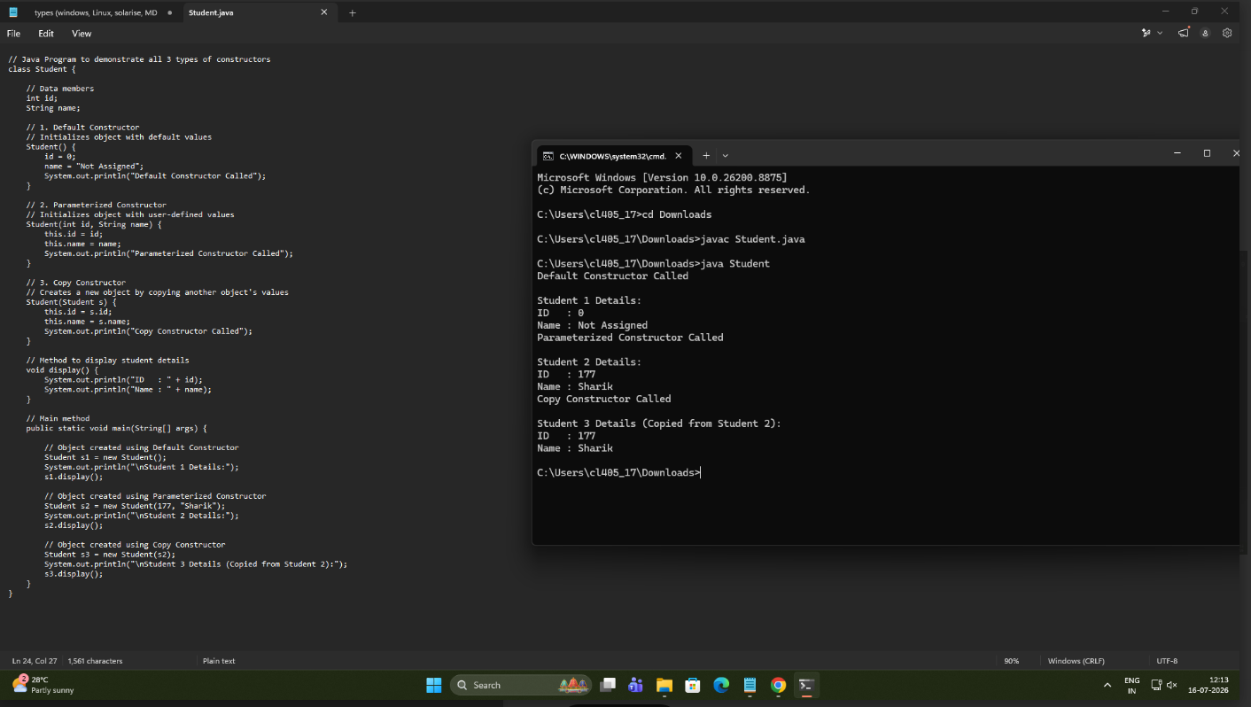

- Develop a Mobile Phone Inventory System using different constructors to initialize mobile details and create duplicate object records.
Code and output:
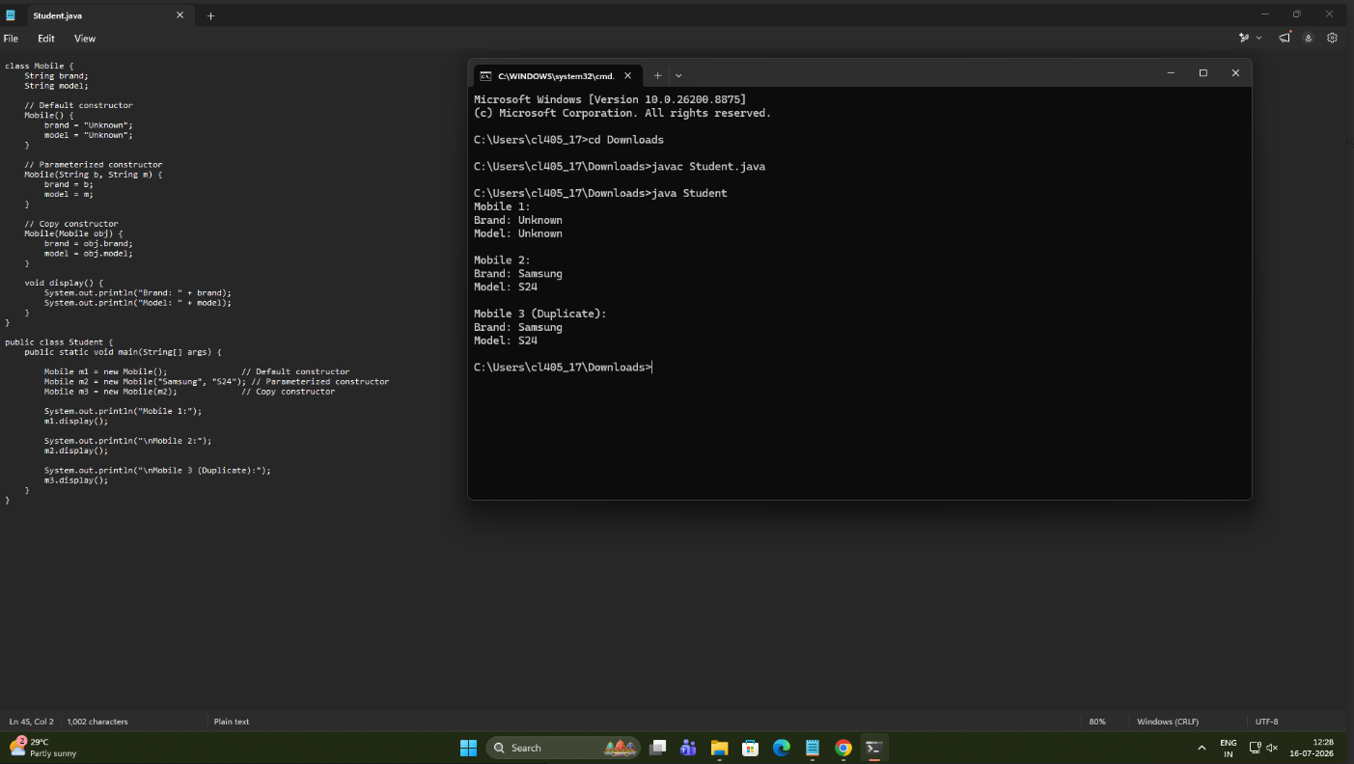

Conclusion:
This assignment taught me to understand and implement default, parameterized, and copy constructors for object initialization.

